Khung:

- ống nhựa rỗng dùng kiểu dư lày: http://thietbidienhuunghi.shopbuild.vn/stores/viewProduct/5741/ong-nhua-pvc-luon-day-dien-panasonic-nano-d-16mm.htm

- Kích thước: 40x40

- vành: rổ nhựa + mút

- Khung <500gr

- cánh quạt 8x4.3

**\*MOTOR: 2 type (Brush & Brushless)**

**- Brush**

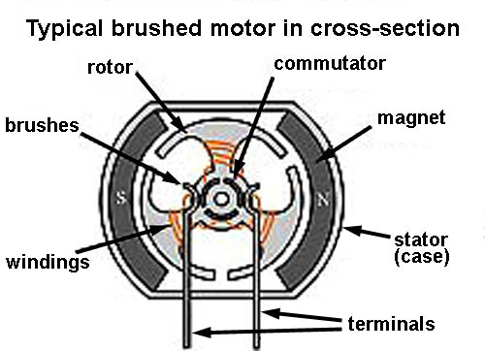

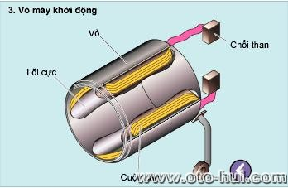

* **Brushless:**

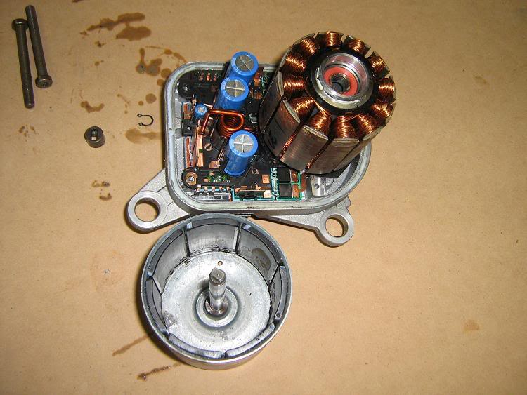

* **Brush vs Brushless:**
  + Brushless motors are often more efficient at converting electricity into mechanical power than brushed motors.
  + The maximum power that can be applied to a BL motor is exceptionally high, limited almost exclusively by heat, which can weaken the magnets.
  + more torque per watt (increased efficiency), increased reliability, reduced noise, longer lifetime (no brush and commutator erosion).

**Motor Himodel 1400kv --- Price: 250k**

* No. Of cells:2-3 Li-Poly
* Max. efficiency current:6-18A (>75%)
* No load current / 10 V:0,7 A
* Dimensions:27.5x30 mm
* Shaft diameter: 3.17 mm
* Weight:47 g
* Recomended prop : 8x4,9x5
* Thrust : 800g +

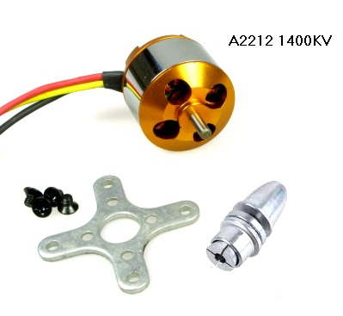

Explain:

* 1400kv or 1400RPM/V (RPM is revolutions per minute). Example:
  + Use power 1V for this: 1400 x 1 = 1400 revolutions/minute.
  + Use power 10V : 1400 x 10 = 14.000 revolutions/minute.
* Max. efficiency current: As the motor performance, the higher efficiency of energy is, the lower of energy loss. Will save battery for longer flight time.
* No load current / 10 V:0,7 A mean: if motor doesn’t work, power loss is 10V : 0,7A per minute.
* Recommends Propeller : 8x4, 9x5:

